**New at your desk**

Rural and co-operative banks in India “possibly” hit by ransomware attack; NPCI temporarily stops payment in affected banks

National Payments Corporation of India temporarily closes all retail payments in the affected banks, and customers will not be able to access the payment systems until restoration is complete C-Edge Technologies Ltd., a technology service provider to co-operative and regional rural banks was “possibly” hit by a [ransomware attack](https://www.thehindu.com/news/national/explained-are-ransomware-attacks-increasing-in-india/article66207006.ece), according to a statement by National Payments Corporation of India (NPCI) on July 31. The Mumbai-based technology provider caters mostly to co-operative and regional rural banks, NPCI added in the statement.

Updated - August 01, 2024 10:01 am IST

Published - July 31, 2024 10:24 pm IST

THE HINDU



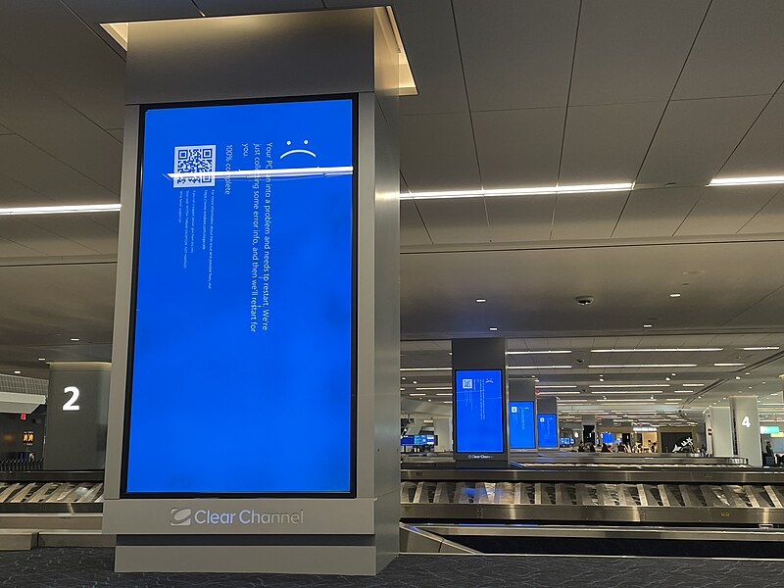

CrowdStrike is sued by shareholders over huge software outage

CrowdStrike has been sued by shareholders who said the cybersecurity company defrauded them by concealing how its inadequate software testing could [cause the July 19 global outage that crashed more than 8 million computers.](https://www.thehindu.com/sci-tech/technology/glitch-in-software-update-may-have-triggered-global-microsoft-crowdstrike-outage-experts/article68423175.ece)

In a proposed class action filed on Tuesday night in the Austin, Texas federal court, shareholders said they learned that CrowdStrike's assurances about its technology were materially false and misleading when a flawed software update disrupted airlines, banks, hospitals and emergency lines around the world.

Published - August 01, 2024 02:11 pm IST – THE HINDU

Google is working on removing AI deepfakes from its search results

The search giant shared that past updates had reduced exposure to explicit image results for queries around deepfakes by over 70% this year

Published - August 01, 2024 11:09 am IST - THE HINDU



Almost all top Indian apps deploy deceptive design practices: ASCI study

Top Indian apps are deploying deceptive design practices which impact user autonomy and informed decision-making by users, a study released on Thursday said.

The study by the Advertising Standards Council of India (ASCI) found that 52 of the top 53 apps have [deceptive UI (user interface)/UX (user experience) practices that can mislead or trick users](https://www.thehindu.com/news/national/centre-invites-public-comments-on-guidelines-to-regulate-dark-patterns/article67280233.ece) into doing something they originally did not intend or want to do.

Published - August 02, 2024 09:19 am IST - MUMBAI



U.S. launches Nvidia antitrust probe after rivals' complaints: Report

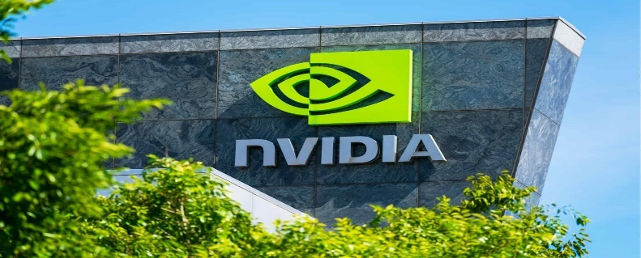

The U.S. Department of Justice (DOJ) has launched an investigation into Nvidia after complaints from competitors that it may have abused its market dominance, said The Information

Published - August 02, 2024 09:04 am IST

The U.S. Department of Justice (DOJ) has launched an investigation into Nvidia after complaints from competitors that it may have abused its market dominance in selling chips that power artificial intelligence, The Information reported on Thursday.

DOJ investigators are looking at whether Nvidia pressured cloud providers to buy multiple Nvidia products, the report said, citing people involved in the discussions.

Microsoft says DDoS attack led to latest global outage of Azure services



This is the second time in one month wherein thousands of Microsoft's customers were impacted.

A host of Azure and Microsoft 365 services were down for over nine hours on Tuesday, July 30 due to a distributed denial-of-service (DDoS) attack, the tech giant said in a statement.

Between 11:45 UTC and 19:43 UTC, [Microsoft](https://indianexpress.com/about/microsoft/) customers globally were unable to connect to its services such as Azure App Services, Application Insights, Azure IoT Central, Azure Log Search Alerts, Azure Policy, the Azure portal, and a subset of Microsoft 365 and Microsoft Purview services.

However, it has not named any specific threat actor to be behind the DDoS attack.

-THE INDIAN EXPRESS

India sees 11% rise in malware attacks, 22% jump in ransomware: Report

Cyber security measures protected businesses from a potential of 46 days of downtime.

Malware attacks in India rose by 11 per cent while ransomware cyber attacks jumped by 22 per cent in 2024, reflecting the escalating nature of cyber threats for businesses, a report by SonicWall said.

Malware attacks rose by 11 per cent to 13,44,566 in 2024 from 12,13,528 in 2023, the 2024 SonicWall Mid-Year Cyber Threat Report said.

Internet of Things (IOT) attacks went up by 59 per cent in the last one year to 16,80,787 in 2024 from 10,57,320 in 2023, it stated.

-THE INDIAN EXPRESS

Microsoft’s GitHub launches playground for AI models



Much like platforms like Hugging Face, GitHub Models also helps developers export and integrate their code into existing workflows making it even easier for them

Updated - August 02, 2024 04:15 pm IST

Published - August 02, 2024 04:14 pm IST

Microsoft’s developer platform GitHub has announced GitHub Models, an interactive sandbox

environment for developers and engineers to explore different AI models for free. Leading models like Meta AI’s Llama 3.1, OpenAI’s GPT-4o and GPT-4o mini, Mistral AI’s Mistral Large 2 and Cohere’s Command will be among the options available. The playground’s beta version has been made available to a limited group of people.

Developers can use GitHub Models to deploy AI models via the built-in playground, test different prompts and model parameters and then launch them into environments like GitHub Codespaces and Visual Studio Code.

OpenAI Is Testing an A.I.-Powered Search Engine



The prominent A.I. start-up said it planned to eventually fold the new technology into its popular online chatbot, ChatGPT.

OpenAI plans to integrate its new search engine technology with its existing online chatbot, ChatGPT, which [launched the A.I. boom](https://www.nytimes.com/2022/12/10/technology/ai-chat-bot-chatgpt.html) when it was released in November 2022. The company said its new technology would respond to questions with up-to-date information from the web while also providing links to relevant sources.

For instance, if someone asks when the Paris Olympics begin and SearchGPT provides a date for the opening ceremony, it might link to a news article.

OpenAI said online publishers such as Reuters are working with the company on the product. “We are committed to a thriving ecosystem of publishers and creators,” the company said, adding that the technology would highlight “high-quality content in a conversational interface with multiple opportunities for users to engage.”

The company also said it was developing ways for publishers to manage how they appeared in answers generated by the new search engine.

Nvidia's new AI chip delay could affect Microsoft, Google, Meta: Report

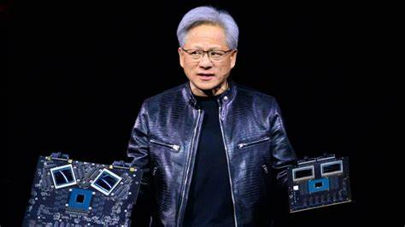

Design flaws could cause a delay of three months or more in the launch of chip giant Nvidia's upcoming artificial intelligence chips, reported The Information

Updated - August 03, 2024 01:43 pm IST

Published - August 03, 2024 01:42 pm IST

Design flaws could cause a delay of three months or more in the launch of chip giant Nvidia's upcoming artificial intelligence chips, tech-focused publication The Information said on Friday.

[The setback could affect customers such as Meta, Google and Microsoft,](https://www.thehindu.com/sci-tech/technology/nvidia-investor-dilemma-how-much-is-too-much-in-a-stock-portfolio/article68406349.ece) who have collectively ordered tens of billions of dollars worth of chips, it said, citing people who help produce chip and server hardware for Nvidia.

**AI chipmaker Nvidia launches tools for developers building humanoid robots**

**The company aims to address the need for vast amounts of data required to train robots by allowing developers to generate large amounts of synthetic data from a handful human tasks**

Published - August 03, 2024 03:20 pm IST

[The Hindu Bureau](https://www.thehindu.com/profile/author/The-Hindu-Bureau-14355/)

Nvidia has announced a new suite of services and tools at Siggraph 2024 to speed up development of humanoid robots. The AI chipmaker has made its tools available to developers and software makers for training and building advanced humanoid robots.

The company introduced the new Nvidia NIM microservices and frameworks for robot simulation and learning as well as the Nvidia OSMO for running multi-stage robotics workloads and a remote-control workflow that helps developers train robots with small amounts of data.

**CrowdStrike rejects Delta Air Lines claims over flight woes due to Microsoft global IT outage**

**CrowdStrike on Sunday rejected a claim by Delta Air Lines that it should be blamed for flight disruptions following a July 19 global outage sparked by a faulty update**

Published - August 05, 2024 10:16 am IST - WASHINGTON

Reuters

CrowdStrike on Sunday rejected a claim by Delta Air Lines that it should be blamed for flight disruptions following a July 19 global outage sparked by a faulty update, and suggested it had minimal potential liability.

Delta CEO Ed Bastian said [last week the outage had cost the U.S. airline $500 million and that it planned to take legal action](https://www.thehindu.com/sci-tech/technology/delta-air-lines-seek-compensation-over-cyber-outage-report/article68462951.ece) to get compensation from the cybersecurity firm.

**IRCTC plugs critical data breach on insurance portal**

**A cybersecurity analyst had flagged vulnerability that gave access to travel details of passengers and also option to change nominee in travel insurance**

Updated - August 05, 2024 09:51 am IST

Published - August 04, 2024 10:22 pm IST - Chennai

The Indian Railway Catering and Tourism Corporation (IRCTC) has addressed a critical vulnerability on its insurance portal that previously allowed unauthorised access to passengers’ travel details and enabled changes to nominee information in the insurance policy.

Cybersecurity researcher Nilabh Rajpoot of Noida discovered the bug after booking train tickets on the IRCTC website and opting for travel insurance. He received a link via SMS that, upon entering the PNR and registered mobile number, opened the travel insurance policy provided by United India Insurance Co Ltd. The link included an option to update nominee details.